Assignment 1

SYSC4906G
Zachary Dredge – 101197514
February 25th, 2026

Part I

Problem Description:
This project aims to model the growth of a basil plant as a discrete event system, through focusing on the link between environmental resources and biological growth. In the real-world, plant growth occurs when a threshold of soil moisture and sunlight are met. The problem to be solved is simulating how the environmental factors of rain and sunlight impact the soil moisture, ultimately triggering growth, or in the case of lack of moisture triggering wilt events.

Model Structure:
Top model: Greenhouse
Coupled Model: Basil plant, comprised of soil and the root of the plant
Atomic models: Nature, Soil, Plant Stem
Nature (previously listed as Environment) will act as the source of natural events. This model will be limited to two of such events, rain and sunshine. The rain event will be generated at random intervals, and sunlight events will occur in a timed cycle to simulate the real-world day/night cycle.
The Soil model will serve as a buffer for moisture retention. To do such, it will maintain a state variable that describes the moisture level of the soil. The model will take rain as an input, which will increment the moisture level. The plant root will request to see the moisture level of the soil, and will expect to receive a signal indicating such soil status.
The plant stem model will simulate the biological growth logic of the basil plant. It will receive sunlight as input, and to grow it will need moist soil. Plant growth will be threshold based, with a variable tracking the nutrient count. When there are enough nutrients, the plant will output a growth event. The plant will also have a variable to track stress. This variable will be incremented when the plant receives a dry signal from the Soil model, and when a certain stress threshold is met the plant will output a wilt event that represents the plant wilting.
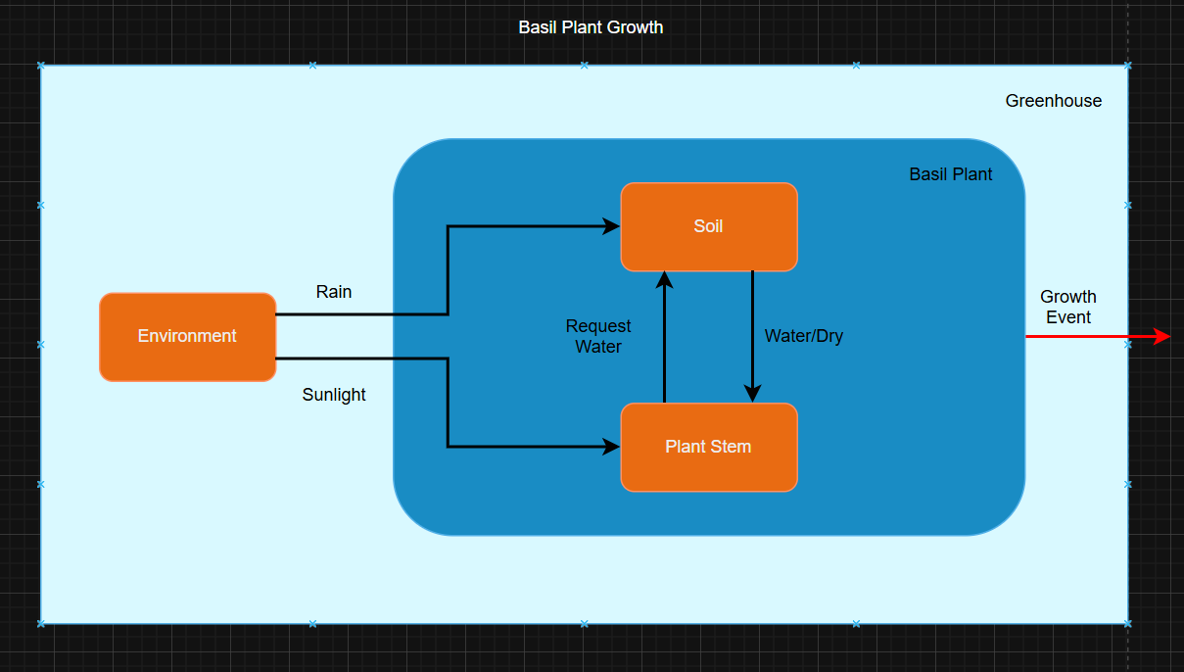
Fig. 1. Conceptual Model Visualization

Part II

Formal Model Specifications

Atomic Models
The formal specifications of each atomic model are defined below. For each model, we will define the set of specifications that define an atomic model in DEVS $<S, X, Y, δ_{int}, δ_{ext}, λ, ta>$.
An important note to make is that for simplicity the system will be modeled such that 1 hour in real-time is the equivalent of 1 time unit in the model space.

Nature
This acts as the source of natural events. This model will be limited to two of such events, rain and sunshine. The rain event will occur at randomly generated intervals, and sunlight events will occur in a timed cycle to simulate the real-world day/night cycle.
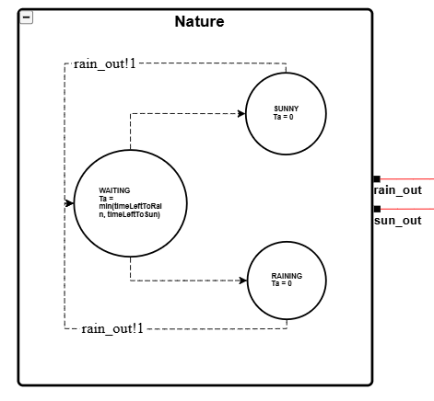
Fig. 2. Nature Atomic Model

$S:$ {WAITING, SUNNY, RAINING}
- State variables:
  - timeLeftToRain
  - timeLeftToSun
  - sunStatus
$X:$ N/A
$Y:$ {rain_out, sun_out}
$δ_{int}:$
- $δ_{int}\left(WAITING\right)=SUNNY$
- $δ_{int}\left(WAITING\right)=RAINING$

Pseudocode of transition function:
If timeLeftToSun <= timeLeftToRain // Checks to see which timer expired first
Transition to SUNNY
Toggle sunStatus
else
Transition to RAINING

- $δ_{int}\left(RAINING\right)=WAITING$
Pseudocode of transition function:
timeLeftToSun -= timeLeftToRain // to maintain variable synchronization
timeLeftToRain = random(5, 10)
transition to WAITING

- $δ_{int}\left(SUNNY\right)=WAITING$
Pseudocode of transition function:
timeLeftToRain -= timeLeftToSun // to maintain variable synchronization
timeLeftToSun = 12
transition to WAITING

$δ_{ext}:$ N/A
$$λ:$$
- $λ\left(SUNNY\right)=sun_out!sun_status | sun_status ϵ \{0, 1\}$
- $λ\left(RAINING\right)=rain_out!1$
$$ta:$$
- $ta\left(WAITING\right)=min⁡(timeLeftToRain, timeLeftToSun)$
- $ta\left(RAINING\right)=0$
- $ta\left(SUNNY\right)=0$

Soil
The soil model will serve as a buffer for moisture retention. To do such, it will maintain a state variable that describes the moisture level of the soil. The model will take rain as an input, which will increment the moisture level. The plant stem will request an update on the soil moisture from this component, and will expect to receive a 1 in return to signal that the soil is moist, or a 0 to indicate it is dry.
An important note about the design is that varying amounts of rain are not being considered. For simplicity, we will assume that when it rains, we increment moistureLevel by one and only one.
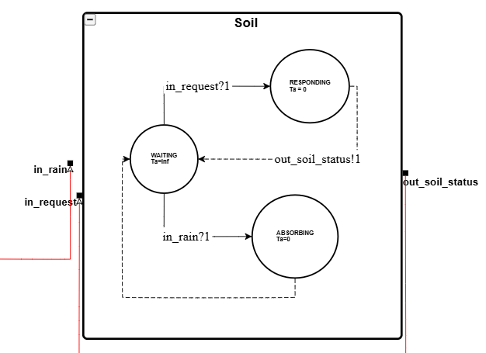
Fig. 3. Soil Atomic Model
$S:$ {WAITING, ABSORBING, RESPONDING}
- State variables
  - moistureLevel
$X:$ {in_rain, in_request}
$Y:$ {out_soil_status}
$δ_{int}:$
- $δ_{int}\left(RESPONDING\right)=WAITING$
- $δ_{int}\left(ABSORBING\right)=WAITING$
$δ_{ext}:$
- $δ_{ext}\left(WAITING, in_rain?1\right)=ABSORBING$
- $δ_{ext}\left(WAITING, in_request?1\right)=RESPONDING$
$$λ:$$
- $λ\left(RESPONDING\right)=\left\{\begin{aligned}out_soil_status!1 if moistureLevel >0 \\ out_soil_status!0 otherwise\end{aligned}\right.$
$$ta:$$
- $ta\left(WAITING\right)=infinity$
- $ta\left(RESPONDING\right)=0$
- $ta\left(ABSORBING\right)=0$

Plant Stem
The plant stem model will simulate the biological growth logic of the basil plant. It will receive sunlight as input, and ask the Soil model to stay updated on the soil status. Plant growth will be threshold based, with a variable tracking the nutrient count. To increment this value, the model will request the soil status from the Soil model, and if it receives a signal indicating it is moist, it will increment nutrientCount. When there are enough nutrients, the plant will output a growth event. The plant will also have a variable to track stress. This variable will be incremented when the plant receives a dry signal from the Soil model, and when a certain stress threshold is met the plant will output a wilt event.
An important feature to note of this model is that it includes the concept of “healing”. This is done by implementing the state variables in such a way that if the stressLevel is greater than 0, the model must first decrement this value back to zero before it can continue to increase its nutrient count.
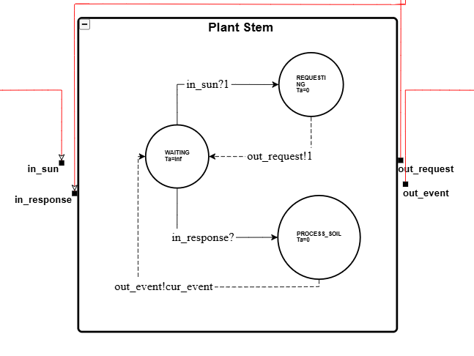
Fig. 4. Plant Stem Atomic Model
$S:$ {WAITING, REQUESTING, PROCESS_SOIL}
- State Variables
  - stessLevel
  - nutientCount
  - isDaytime
  - pendingReset
$X:$ {in_sun, in_response}
$Y:$ {out_request, out_event}
$$δ_{int}:$$
- $δ_{int}\left(REQUESTING\right)=WAITING$
- $δ_{int}\left(PROCESS_SOIL\right)=WAITING$
  - Increment nutrientCount
- $δ_{int}\left(WAITING\right)=REQUESTING$
  - If isDaytime transition to REQUESTING
$δ_{ext}:$
- $δ_{ext}\left(WAITING, in_sun?1\right)=WAITING$
  - No state transition, just update isDaytime flag
- $δ_{ext}\left(WAITING, in_response?1\right)=PROCESS_SOIL$
Pseudocode of transition function:
If stressLevel > 0
stressLevel-- // heal before growing again
Else
nutrientCount++
if nutrientCount >= 10
nutrientCount = 0

$$λ:$$
- $λ\left(REQUESTING\right)=out_request!1$
- $λ\left(PROCESS_SOIL\right)=\left\{\begin{aligned}out_event!1 if nutrientCount≥10 \\ out_event!0 if stessLevel≥5\end{aligned}\right.$
$$ta:$$
- $ta\left(WAITING\right)=2.0$
- $ta(PROCESS_SOIL)=0$
- $ta\left(REQUESTING\right)=0$

Coupled Models
The formal specification of the sole coupled model is defined below. For such model, we will define the set of specifications that define a couple model in DEVS $<X, Y, D, \left\{M_{i}\right\}, {\{I}_{i}\}, \{Z_{ij}\}, Select>$.

Basil Plant
This model represents the coupling of the Soil and Plant Stem models.
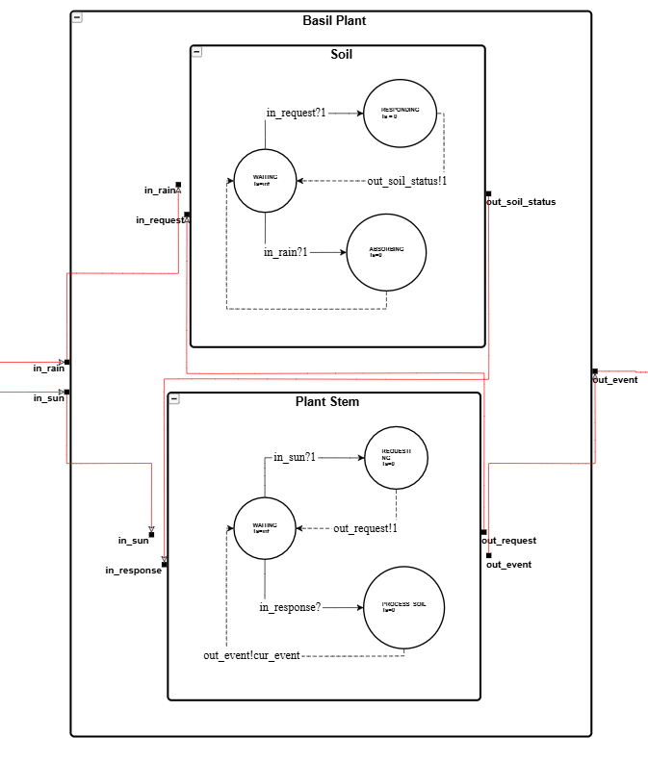
Fig. 5. Basil Plant Coupled Model
$X:$ {in_rain, in_sun}
$Y:$ {out_event}
$M:$ {Plant Stem, Soil}
$EIC:$ {(Basil Plant.in_rain, Soil.in_rain), (Basil Plant.in_sun, Plant Stem.in_sun)}
$EOC:$ {(Plant Stem.out_event, Basil Plant.out_event)}
$IC:$ {(Plant Stem.out_request, Soil.in_request), Soil.out_soil_status, Plant Stem.in_response)}
$SELECT:$ {(Soil, Plant Stem)} = Plant Stem

Top Model – Greenhouse
This coupling represents the system top model, which is comprised of the Basil Plant and Nature.
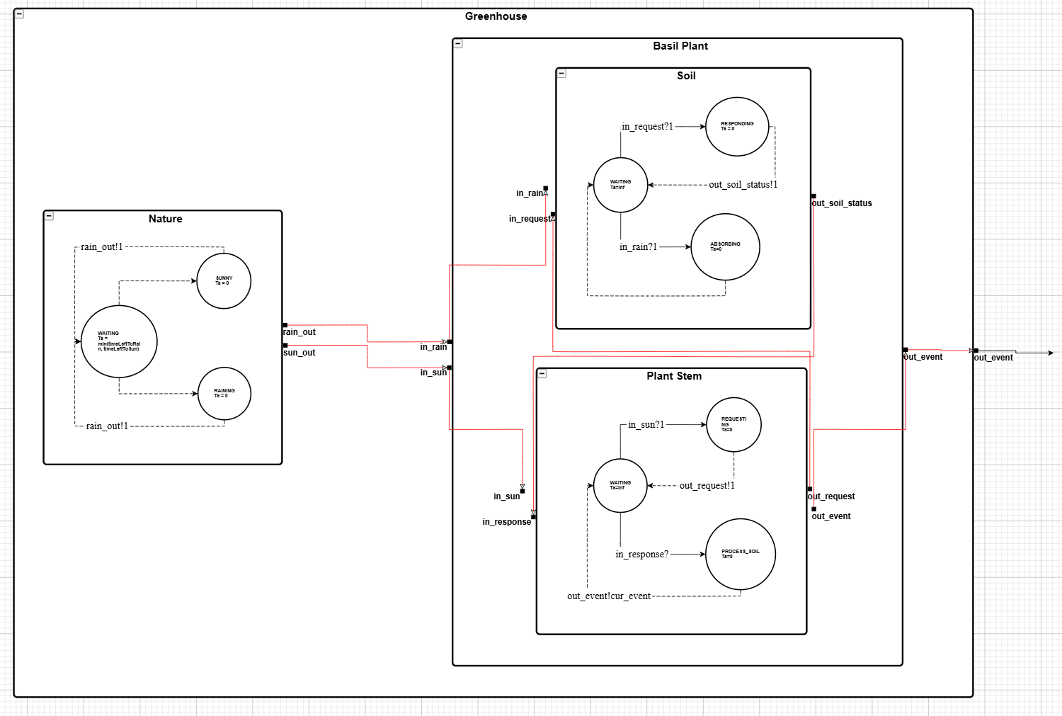
Fig. 6. Greenhouse Top Model
Finally, we have the definition of the top model (Greenhouse) as follows:
$X:$ N/A
$Y:$ {out_event}
$M:$ {Nature, Basil Plant}
$EIC:$ N/A
$EOC:$ {(Basil Plant.out_event, Greenhouse.out_event)}
$IC:$ {(Nature.rain_out, Basil Plant.in_rain), Nature.sun_out, Basil Plant.in_sun)}

Experimental Framework
The following section will detail a series of tests that will be run to verify the functionality of each component in the model.

Nature

Experiment 1: Solar Cycle
This experiment will aim to verify the sun cycles correctly within the component. The correct behaviour is that the sun’s status should switch between on and off every 12 hours. As defined above, for simplicity’s sake each hour in real-time will be represented as 1 time unit of the simulation space. As such to test this functionality we will run the simulation for 48 time units and verify that the sun’s status is toggled every 12 time units, totally 4 toggles.

Experiment 2: Rain Cycle
This experiment will aim to verify the interval pattern on the rain cycle. To do so, we will run the simulation for 100 time units and verify that the rain pattern is random. This experiment will need to be run multiple times to verify no fixed pattern exists between simulation runs. What we aim to observe here is the rain_out port firing on a random schedule.

Soil

Experiment 1: Soil Absorption
This experiment will verify that the model correctly responds to inputs from the in_rain port. To test this, we will send several inputs through the port and verify that the moistureLevel state variable is updated with each input. We will also ensure there is no output after receiving an input.

Experiment 2: Soil Life Cycle Test
This experiment will aim to verify that the soil properly processes rain events. This will be done by firing three inputs through the in_rain port consecutively, followed by three calls to the in_request port. The corresponding output, for each input, should be a 1 through the out_soil_status port, indicating that the soil is wet. To test the full life cycle, the final command will be an in_request input, which should output that the soil is dry. This is the final expected output as with each output corresponding wet signal (the first three calls of the experiment) the moistureLevel state variable is decremented by one, and as such following three consecutive requests will have a final value of 0.

Experiment 3: Race Condition Testing
This experiment was added after completing several rounds of testing and model coupling. It became apparent when testing the overall top model (Greenhouse) that race conditions could occur with the in_rain and in_request ports. Through this testing, we could see that when a race condition did occur on these ports, the Plant Stem model would request the soil status from the Soil model but never receive a response. This resulted in the nutrientCount variable of the Plant Stem model not incrementing as expected, thereby delaying growth.
To test that this race condition is being handled properly, we will provide the model with multiple inputs at the same time to observe its response. The correct response is that when both in_rain and in_request ports fire simultaneously that the moistureLevel will increase before once again decrementing.

Plant Stem

Experiment 1: Growth Threshold
This experiment will aim to verify that when the growth threshold is met, a growth event occurs. To do so we will fire the in_response port with a value of 1 (indicating the soil is wet) ten consecutive times, with the expectation being that a growth event is outputted on the tenth signal.
An important note for this experiment is that over the course of testing the top Greenhouse model, it became apparent that a threshold value of ten was too high as little to no growth events occurred. This will be discussed in more depth later in the report, but for the sake of this experiment the threshold will remain at ten.

Experiment 2: Wilt Threshold
This experiment will aim to verify that when the wilt threshold is met, a growth event occurs. To do so we will fire five consecutive 0’s to the in_response port (indicating dry soil) and test if a wilt event is outputted on the fifth signal. Additionally, we will continue to fire dry signals beyond the threshold value to ensure that wilt events continue to occur as long as the stress state variable exceeds the threshold value.

Experiment 3: Sun Polling Loop
This experiment will aim to verify the polling functionality of the model. When the sun is present, the model should poll the soil with requests for the soil status every 2 time units. To verify this functionality, we will observe when the out_request port is fired.
Additionally, we can observe through the output that the model does not perform a state transition if it polls but sees that the sun is not up (i.e. isDaytime = 0).

Basil Plant

Experiment 1: Lifecycle Loop
This experiment will aim to verify the internal couplings between the Soil and the Plant Stem models. To test this, we will set moisture = 2 and manually send an input of 1 to in_sun to observe the outcome. This should result in the Plant Stem firing the out_request port to the Soil model, which should then respond with WATER and decrement moisture by 1.

Greenhouse (Top Model)
Testing the top model is essentially combining all the above experiments. To perform this experiment, we will run the simulation for 100 time units. Additionally, to view the trend of growth and wilt events we will run the simulation over 200, 300, 500, and 1000 time units.

Part III
The following sections detail the results of the defined experiments from Part II. The full output files are listed on the GitHub page.
As a small note, the outputs contain components labeled as readers. These components represent input being read from an input file and being fired on their respective port. The name convention is {PORT_NAME}_reader. For example, sun_reader represents inputs being fired through the sun_in port of the Stem model, rain_reader represents inputs being fired through the rain_in port of the Soil model.

Nature

Experiment 1 & 2 Results
For simplicity, implementing experiments 1 and 2 was combined into a single experiment. The following is a snippet of the output, the full output can be found in the GitHub repo.
0,1,nature_model,,timeLeftToRain: 6 timeLeftToSun: 12 sunStatus: 0 state: 0
6,1,nature_model,,timeLeftToRain: 6 timeLeftToSun: 12 sunStatus: 0 state: 2 // Transition to RAINING

6,1,nature_model,rain_out,1
6,1,nature_model,,timeLeftToRain: 8 timeLeftToSun: 6 sunStatus: 0 state: 0 // Transition to WAITING

12,1,nature_model,,timeLeftToRain: 8 timeLeftToSun: 6 sunStatus: 1 state: 1 // Transition to SUN
12,1,nature_model,sun_out,1
12,1,nature_model,,timeLeftToRain: 2 timeLeftToSun: 12 sunStatus: 1 state: 0 // Transition to WAITING

14,1,nature_model,,timeLeftToRain: 2 timeLeftToSun: 12 sunStatus: 1 state: 2 // Transition to RAIN
14,1,nature_model,rain_out,1
14,1,nature_model,,timeLeftToRain: 6 timeLeftToSun: 10 sunStatus: 1 state: 0 // Transition to WAITING

…
24,1,nature_model,,timeLeftToRain: 7 timeLeftToSun: 4 sunStatus: 0 state: 1
24,1,nature_model,sun_out,0
24,1,nature_model,,timeLeftToRain: 3 timeLeftToSun: 12 sunStatus: 0 state: 0

…
36,1,nature_model,,timeLeftToRain: 8 timeLeftToSun: 4 sunStatus: 1 state: 1
36,1,nature_model,sun_out,1
36,1,nature_model,,timeLeftToRain: 4 timeLeftToSun: 12 sunStatus: 1 state: 0

To verify the first experiment, we can look at the timeLeftToSun and sunStatus variables. At 12 seconds we see that the model transitions to the SUNNY state, resets timeLeftToSun to 12, and toggles sunStatus to on. Moving forwards through time, we see that at each 12 second interval, the value of sunStatus flips. Thus, this output confirms the correct functionality of this portion of the model.
To verify the second experiment, we can look the intervals between the rain_out events. To verify the randomness of the rain cycles, we need to see that no pattern arises when running multiple trials. In this first trial, we can see that rain events occur at t = {6, 14, 20, 27, 32, 40, 45, 51, 58, 67, 73, 80, 87, 92}. Running this experiment multiple times, we see that the time intervals of rain are in fact random. Five separate trials are included in the repo, and they confirm that the events do occur randomly.

Soil

Experiment 1 & 2 Results
time,model_id,model_name,port_name,data
0,1,soil_model,,moistureLevel: 0 state: 0
0,2,request_reader,,4
0,3,rain_reader,,1

1,1,soil_model,,moistureLevel: 1 state: 1
1,3,rain_reader,out,1
1,3,rain_reader,,1
1,1,soil_model,,moistureLevel: 1 state: 0

2,1,soil_model,,moistureLevel: 2 state: 1
2,3,rain_reader,out,1
2,3,rain_reader,,1
2,1,soil_model,,moistureLevel: 2 state: 0

3,1,soil_model,,moistureLevel: 3 state: 1
3,3,rain_reader,out,1
3,3,rain_reader,,inf
3,1,soil_model,,moistureLevel: 3 state: 0

4,1,soil_model,,moistureLevel: 3 state: 2
4,2,request_reader,out,1
4,2,request_reader,,1
4,1,soil_model,out_soil_status,1
4,1,soil_model,,moistureLevel: 2 state: 0

5,1,soil_model,,moistureLevel: 2 state: 2
5,2,request_reader,out,1
5,2,request_reader,,1
5,1,soil_model,out_soil_status,1
5,1,soil_model,,moistureLevel: 1 state: 0

6,1,soil_model,,moistureLevel: 1 state: 2
6,2,request_reader,out,1
6,2,request_reader,,1
6,1,soil_model,out_soil_status,1
6,1,soil_model,,moistureLevel: 0 state: 0

7,1,soil_model,,moistureLevel: 0 state: 2
7,2,request_reader,out,1
7,2,request_reader,,inf
7,1,soil_model,out_soil_status,0
7,1,soil_model,,moistureLevel: 0 state: 0
7,1,soil_model,,moistureLevel: 0 state: 0
7,2,request_reader,,inf
7,3,rain_reader,,inf

Once again, we can combine our experiments into a singular test case.
As we can see from the above, the model receives three consecutive rain inputs. During each rain input, the model receives the input and increments the moistureLevel variable by 1 and transitions to state 1 which is the ABSORBING state. Following this, the output indicates that the next input is being read and the model transitions back to WAITING immediately following its entry to ABSORBING. This transition is correct as ABOSRBING is a transient state.
Moving to the inputs regarding soil status requests (4-7), we see that the model decrements the moisture level by 1 after each request, and outputs either a 1 (wet) or 0 (dry). As expected, the first three requests result in out_soil_status outputting a 1, and as expected the fourth output is a 0. The output also indicates that the model properly transitions between waiting responding waiting.
As mentioned above, by testing the soil lifecycle we also ensure that the absorption logic works as intended.

Experiment 3 Results
time,model_id,model_name,port_name,data
0,1,soil_model_concurrent,,moistureLevel: 0 state: 0
0,2,request_reader_concurrent,,2
0,3,rain_reader_concurrent,,1

1,1,soil_model_concurrent,,moistureLevel: 1 state: 1
1,3,rain_reader_concurrent,out,1
1,3,rain_reader_concurrent,,1
1,1,soil_model_concurrent,,moistureLevel: 1 state: 0

2,1,soil_model_concurrent,,moistureLevel: 2 state: 2
2,2,request_reader_concurrent,out,1
2,2,request_reader_concurrent,,1
2,3,rain_reader_concurrent,out,1
2,3,rain_reader_concurrent,,1
2,1,soil_model_concurrent,out_soil_status,1
2,1,soil_model_concurrent,,moistureLevel: 1 state: 0

3,1,soil_model_concurrent,,moistureLevel: 2 state: 2
3,2,request_reader_concurrent,out,1
3,2,request_reader_concurrent,,3
3,3,rain_reader_concurrent,out,1
3,3,rain_reader_concurrent,,inf
3,1,soil_model_concurrent,out_soil_status,1
3,1,soil_model_concurrent,,moistureLevel: 1 state: 0

6,1,soil_model_concurrent,,moistureLevel: 1 state: 2
6,2,request_reader_concurrent,out,1
6,2,request_reader_concurrent,,1
6,1,soil_model_concurrent,out_soil_status,1
6,1,soil_model_concurrent,,moistureLevel: 0 state: 0

7,1,soil_model_concurrent,,moistureLevel: 0 state: 2
7,2,request_reader_concurrent,out,1
7,2,request_reader_concurrent,,inf
7,1,soil_model_concurrent,out_soil_status,0
7,1,soil_model_concurrent,,moistureLevel: 0 state: 0
7,1,soil_model_concurrent,,moistureLevel: 0 state: 0
7,2,request_reader_concurrent,,inf
7,3,rain_reader_concurrent,,inf

From the above output, we can confirm the correct functionality in the presence of race conditions. This experiment was designed to have race conditions at t = {2, 3}, where the resulting moistureLevel would equal 1 after t = 3. At t = 2 and t = 3, we see that first the moistureLevel is incremented as in_rain fires, and later moistureLevel decrements as in_request fires. With moistureLevel having a final value of 1, we can confirm that the model functions as intended.
Beyond these time points, we see that the moistureLevel correctly decrements at time 6, and does not become negative at time 7 after in_request fires.

Plant Stem

Experiment 1 Results
time,model_id,model_name,port_name,data
0,1,soil_model,,moistureLevel: 0 state: 0
0,2,request_reader,,4
0,3,rain_reader,,1

1,1,soil_model,,moistureLevel: 1 state: 1
1,3,rain_reader,out,1
1,3,rain_reader,,1
1,1,soil_model,,moistureLevel: 1 state: 0

2,1,soil_model,,moistureLevel: 2 state: 1
2,3,rain_reader,out,1
2,3,rain_reader,,1
2,1,soil_model,,moistureLevel: 2 state: 0

3,1,soil_model,,moistureLevel: 3 state: 1
3,3,rain_reader,out,1
3,3,rain_reader,,inf
3,1,soil_model,,moistureLevel: 3 state: 0

4,1,soil_model,,moistureLevel: 3 state: 2
4,2,request_reader,out,1
4,2,request_reader,,1
4,1,soil_model,out_soil_status,1
4,1,soil_model,,moistureLevel: 2 state: 0

5,1,soil_model,,moistureLevel: 2 state: 2
5,2,request_reader,out,1
5,2,request_reader,,1
5,1,soil_model,out_soil_status,1
5,1,soil_model,,moistureLevel: 1 state: 0

6,1,soil_model,,moistureLevel: 1 state: 2
6,2,request_reader,out,1
6,2,request_reader,,1
6,1,soil_model,out_soil_status,1
6,1,soil_model,,moistureLevel: 0 state: 0

7,1,soil_model,,moistureLevel: 0 state: 2
7,2,request_reader,out,1
7,2,request_reader,,inf
7,1,soil_model,out_soil_status,0
7,1,soil_model,,moistureLevel: 0 state: 0
7,1,soil_model,,moistureLevel: 0 state: 0
7,2,request_reader,,inf
7,3,rain_reader,,inf

From the above, we see that the model is properly cycling through the states and incrementing the nutrientCount as the stem receives responses from the mock soil model. With each WATER input, we see that the stem transitions into PROCESS_SOIL, increments the nutrientCount, and finally returns to WAITING. On the tenth input we see that the out_event port outputs 1, indicating a growth event. This cycle is as expected.

Experiment 2 Results
0,1,stem_model,,stressLevel: 0 nutrientCount: 0 is_daytime: 0 state: 0
0,2,response_reader,,1
0,3,sun_reader,,inf

1,1,stem_model,,stressLevel: 1 nutrientCount: 0 is_daytime: 0 state: 2
1,2,response_reader,out,0
1,2,response_reader,,1
1,1,stem_model,,stressLevel: 1 nutrientCount: 0 is_daytime: 0 state: 0

2,1,stem_model,,stressLevel: 2 nutrientCount: 0 is_daytime: 0 state: 2
2,2,response_reader,out,0
2,2,response_reader,,1
2,1,stem_model,,stressLevel: 2 nutrientCount: 0 is_daytime: 0 state: 0

3,1,stem_model,,stressLevel: 3 nutrientCount: 0 is_daytime: 0 state: 2
3,2,response_reader,out,0
3,2,response_reader,,1
3,1,stem_model,,stressLevel: 3 nutrientCount: 0 is_daytime: 0 state: 0

4,1,stem_model,,stressLevel: 4 nutrientCount: 0 is_daytime: 0 state: 2
4,2,response_reader,out,0
4,2,response_reader,,1
4,1,stem_model,,stressLevel: 4 nutrientCount: 0 is_daytime: 0 state: 0
5,1,stem_model,,stressLevel: 5 nutrientCount: 0 is_daytime: 0 state: 2
5,2,response_reader,out,0
5,2,response_reader,,1
5,1,stem_model,out_event,0
5,1,stem_model,,stressLevel: 5 nutrientCount: 0 is_daytime: 0 state: 0

6,1,stem_model,,stressLevel: 6 nutrientCount: 0 is_daytime: 0 state: 2
6,2,response_reader,out,0
6,2,response_reader,,1
6,1,stem_model,out_event,0
6,1,stem_model,,stressLevel: 6 nutrientCount: 0 is_daytime: 0 state: 0

7,1,stem_model,,stressLevel: 7 nutrientCount: 0 is_daytime: 0 state: 2
7,2,response_reader,out,0
7,2,response_reader,,1
7,1,stem_model,out_event,0
7,1,stem_model,,stressLevel: 7 nutrientCount: 0 is_daytime: 0 state: 0

8,1,stem_model,,stressLevel: 8 nutrientCount: 0 is_daytime: 0 state: 2
8,2,response_reader,out,0
8,2,response_reader,,inf
8,1,stem_model,out_event,0
8,1,stem_model,,stressLevel: 8 nutrientCount: 0 is_daytime: 0 state: 0
8,1,stem_model,,stressLevel: 8 nutrientCount: 0 is_daytime: 0 state: 0
8,2,response_reader,,inf
8,3,sun_reader,,inf

As with experiment 1, the output of experiment 2 confirms the proper cycle of a wilt event. From the output we see that the model properly receives consecutive dry signals, increases stressLevel with each before on the fifth and final input placing a 0 signal on the out_event port to indicate a wilt event. Following the initial wilt event, we see that a wilt event occurs at each of the following time points as a dry signal is received. This output confirms the logic of continuously wilting.

Experiment 3 Results
0,1,stem_model,,stressLevel: 0 nutrientCount: 0 is_daytime: 0 state: 0
0,2,response_reader,,inf
0,3,sun_reader,,1

1,1,stem_model,,stressLevel: 0 nutrientCount: 0 is_daytime: 1 state: 0
1,3,sun_reader,out,1
1,3,sun_reader,,inf

3,1,stem_model,,stressLevel: 0 nutrientCount: 0 is_daytime: 1 state: 1
3,1,stem_model,out_request,1
3,1,stem_model,,stressLevel: 0 nutrientCount: 0 is_daytime: 1 state: 0

5,1,stem_model,,stressLevel: 0 nutrientCount: 0 is_daytime: 1 state: 1
5,1,stem_model,out_request,1
5,1,stem_model,,stressLevel: 0 nutrientCount: 0 is_daytime: 1 state: 0

7,1,stem_model,,stressLevel: 0 nutrientCount: 0 is_daytime: 1 state: 1
7,1,stem_model,out_request,1
7,1,stem_model,,stressLevel: 0 nutrientCount: 0 is_daytime: 1 state: 0

9,1,stem_model,,stressLevel: 0 nutrientCount: 0 is_daytime: 1 state: 1
9,1,stem_model,out_request,1
9,1,stem_model,,stressLevel: 0 nutrientCount: 0 is_daytime: 1 state: 0

11,1,stem_model,,stressLevel: 0 nutrientCount: 0 is_daytime: 1 state: 1
11,1,stem_model,out_request,1
11,1,stem_model,,stressLevel: 0 nutrientCount: 0 is_daytime: 1 state: 0
11,1,stem_model,,stressLevel: 0 nutrientCount: 0 is_daytime: 1 state: 0
11,2,response_reader,,inf
11,3,sun_reader,,inf

From the above, we can confirm that the polling functions as intended. At time 1, we can see that the sun arrives, and every 2 time units from this point the out_request port fires a request to the Soil model. For the purposes of the experiment, we do not consider the return as we are just focused on the firing of the port.
As described above, we also need to observe that the model does not perform a state transition if the sun is not out. This functionality was not confirmed here, but can be seen when running the overall top model. In particular, when running the 100 time unit simulation this can be seen at t = 2.

Experiment 4
0,1,stem_model,,stressLevel: 0 nutrientCount: 0 is_daytime: 0 state: 0
0,2,response_reader,,1
0,3,sun_reader,,inf

1,1,stem_model,,stressLevel: 1 nutrientCount: 0 is_daytime: 0 state: 2
1,2,response_reader,out,0
1,2,response_reader,,1
1,1,stem_model,,stressLevel: 1 nutrientCount: 0 is_daytime: 0 state: 0

2,1,stem_model,,stressLevel: 2 nutrientCount: 0 is_daytime: 0 state: 2
2,2,response_reader,out,0
2,2,response_reader,,1
2,1,stem_model,,stressLevel: 2 nutrientCount: 0 is_daytime: 0 state: 0

3,1,stem_model,,stressLevel: 3 nutrientCount: 0 is_daytime: 0 state: 2
3,2,response_reader,out,0
3,2,response_reader,,1
3,1,stem_model,,stressLevel: 3 nutrientCount: 0 is_daytime: 0 state: 0

4,1,stem_model,,stressLevel: 4 nutrientCount: 0 is_daytime: 0 state: 2
4,2,response_reader,out,0
4,2,response_reader,,1
4,1,stem_model,,stressLevel: 4 nutrientCount: 0 is_daytime: 0 state: 0

5,1,stem_model,,stressLevel: 5 nutrientCount: 0 is_daytime: 0 state: 2
5,2,response_reader,out,0
5,2,response_reader,,1
5,1,stem_model,out_event,0
5,1,stem_model,,stressLevel: 5 nutrientCount: 0 is_daytime: 0 state: 0

6,1,stem_model,,stressLevel: 4 nutrientCount: 0 is_daytime: 0 state: 2
6,2,response_reader,out,1
6,2,response_reader,,1
6,1,stem_model,,stressLevel: 4 nutrientCount: 0 is_daytime: 0 state: 0

7,1,stem_model,,stressLevel: 3 nutrientCount: 0 is_daytime: 0 state: 2
7,2,response_reader,out,1
7,2,response_reader,,1
7,1,stem_model,,stressLevel: 3 nutrientCount: 0 is_daytime: 0 state: 0

8,1,stem_model,,stressLevel: 2 nutrientCount: 0 is_daytime: 0 state: 2
8,2,response_reader,out,1
8,2,response_reader,,1
8,1,stem_model,,stressLevel: 2 nutrientCount: 0 is_daytime: 0 state: 0

9,1,stem_model,,stressLevel: 1 nutrientCount: 0 is_daytime: 0 state: 2
9,2,response_reader,out,1
9,2,response_reader,,1
9,1,stem_model,,stressLevel: 1 nutrientCount: 0 is_daytime: 0 state: 0

10,1,stem_model,,stressLevel: 0 nutrientCount: 0 is_daytime: 0 state: 2
10,2,response_reader,out,1
10,2,response_reader,,1
10,1,stem_model,,stressLevel: 0 nutrientCount: 0 is_daytime: 0 state: 0

11,1,stem_model,,stressLevel: 0 nutrientCount: 1 is_daytime: 0 state: 2
11,2,response_reader,out,1
11,2,response_reader,,1
11,1,stem_model,,stressLevel: 0 nutrientCount: 1 is_daytime: 0 state: 0

12,1,stem_model,,stressLevel: 0 nutrientCount: 2 is_daytime: 0 state: 2
12,2,response_reader,out,1
12,2,response_reader,,1
12,1,stem_model,,stressLevel: 0 nutrientCount: 2 is_daytime: 0 state: 0

13,1,stem_model,,stressLevel: 0 nutrientCount: 3 is_daytime: 0 state: 2
13,2,response_reader,out,1
13,2,response_reader,,1
13,1,stem_model,,stressLevel: 0 nutrientCount: 3 is_daytime: 0 state: 0

14,1,stem_model,,stressLevel: 0 nutrientCount: 4 is_daytime: 0 state: 2
14,2,response_reader,out,1
14,2,response_reader,,1
14,1,stem_model,,stressLevel: 0 nutrientCount: 4 is_daytime: 0 state: 0

15,1,stem_model,,stressLevel: 0 nutrientCount: 5 is_daytime: 0 state: 2
15,2,response_reader,out,1
15,2,response_reader,,1
15,1,stem_model,,stressLevel: 0 nutrientCount: 5 is_daytime: 0 state: 0

16,1,stem_model,,stressLevel: 0 nutrientCount: 6 is_daytime: 0 state: 2
16,2,response_reader,out,1
16,2,response_reader,,1
16,1,stem_model,,stressLevel: 0 nutrientCount: 6 is_daytime: 0 state: 0

17,1,stem_model,,stressLevel: 0 nutrientCount: 7 is_daytime: 0 state: 2
17,2,response_reader,out,1
17,2,response_reader,,1
17,1,stem_model,,stressLevel: 0 nutrientCount: 7 is_daytime: 0 state: 0

18,1,stem_model,,stressLevel: 0 nutrientCount: 8 is_daytime: 0 state: 2
18,2,response_reader,out,1
18,2,response_reader,,1
18,1,stem_model,,stressLevel: 0 nutrientCount: 8 is_daytime: 0 state: 0

19,1,stem_model,,stressLevel: 0 nutrientCount: 9 is_daytime: 0 state: 2
19,2,response_reader,out,1
19,2,response_reader,,1
19,1,stem_model,,stressLevel: 0 nutrientCount: 9 is_daytime: 0 state: 0

20,1,stem_model,,stressLevel: 0 nutrientCount: 10 is_daytime: 0 state: 2
20,2,response_reader,out,1
20,2,response_reader,,inf
20,1,stem_model,out_event,1
20,1,stem_model,,stressLevel: 0 nutrientCount: 0 is_daytime: 0 state: 0

22,1,stem_model,,stressLevel: 0 nutrientCount: 0 is_daytime: 0 state: 0

24,1,stem_model,,stressLevel: 0 nutrientCount: 0 is_daytime: 0 state: 0
24,1,stem_model,,stressLevel: 0 nutrientCount: 0 is_daytime: 0 state: 0
24,2,response_reader,,inf
24,3,sun_reader,,inf

From the above output we can see that through time 1-5, the plant becomes increasingly stressed before finally outputting a wilt event. From this point we see through time points 6-10 the plant receives a wet signal from the Soil model, and decrements stressLevel back to 0. At this point, we then see more wet signals being received and nutrientCount climbing before finally reaching a growth event at time = 20. This output confirms the stress and eventual recovery logic of the plant.

Basil Plant
0,2,plant_stem,,stressLevel: 0 nutrientCount: 0 state: 0
0,3,plant_soil,,moistureLevel: 0 state: 0
0,4,sun_reader,,3
0,5,rain_reader,,1

1,3,plant_soil,,moistureLevel: 1 state: 1
1,5,rain_reader,out,1
1,5,rain_reader,,1
1,3,plant_soil,,moistureLevel: 1 state: 0

2,3,plant_soil,,moistureLevel: 2 state: 1
2,5,rain_reader,out,1
2,5,rain_reader,,inf
2,3,plant_soil,,moistureLevel: 2 state: 0

3,2,plant_stem,,stressLevel: 0 nutrientCount: 0 state: 1
3,4,sun_reader,out,1
3,4,sun_reader,,inf
3,2,plant_stem,out_request,1
3,2,plant_stem,,stressLevel: 0 nutrientCount: 0 state: 0
3,3,plant_soil,,moistureLevel: 2 state: 2
3,2,plant_stem,,stressLevel: 0 nutrientCount: 1 state: 2
3,3,plant_soil,out_soil_status,1
3,3,plant_soil,,moistureLevel: 1 state: 0
3,2,plant_stem,,stressLevel: 0 nutrientCount: 1 state: 0
3,2,plant_stem,,stressLevel: 0 nutrientCount: 1 state: 0
3,3,plant_soil,,moistureLevel: 1 state: 0
3,4,sun_reader,,inf
3,5,rain_reader,,inf

From the above, we see that the coupling of the Soil and Plant Stem models performs as intended. At time 1 and 2 we see that Soil receives a rain input, which increments the moisture level by 2. This ensures that the external input coupling of the in_rain port functions as intended.
At time 3, we see the internal couplings and their interactions. First the stem receives a sun signal, which then transitions Plant Stem to the REQUESTING state. The Soil model receives the request from Plant Stem, checks the moisture level, responds with a wet signal and decrements the moisture level. From here, we see that Plant Stem receives the response, and transitions to PROCESSING_SOIL where it increments nutrientCount by one. This cycle demonstrates that the internal couplings are correctly implemented.

Greenhouse

100 Time Unit Simulation
The following is the output of a 100 time unit simulation. The threshold for a growth event was set at nutrientCount = 5. The below output has been annotated with comments indicating the operations occurring at specific time points.
time,model_id,model_name,port_name,data
0,2,plant_stem,,stressLevel: 0 nutrientCount: 0 isDaytime: 0 state: 0
0,3,plant_soil,,moistureLevel: 0 state: 0
0,4,nature_model,,timeLeftToRain: 6 timeLeftToSun: 12 sunStatus: 0 state: 0

// Polling cycle, isDaytime = 0 so the Stem model stays in WAITING
2,2,plant_stem,,stressLevel: 0 nutrientCount: 0 isDaytime: 0 state: 0

// Polling cycle, isDaytime = 0 so the Stem model stays in WAITING
4,2,plant_stem,,stressLevel: 0 nutrientCount: 0 isDaytime: 0 state: 0

// First rain event. timeLeftToRain expires, triggering the rain_out port. The plant model receives this as input and increments moistureLevel
6,2,plant_stem,,stressLevel: 0 nutrientCount: 0 isDaytime: 0 state: 0
6,4,nature_model,,timeLeftToRain: 6 timeLeftToSun: 12 sunStatus: 0 state: 2
6,3,plant_soil,,moistureLevel: 1 state: 1
6,4,nature_model,rain_out,1
6,4,nature_model,,timeLeftToRain: 10 timeLeftToSun: 6 sunStatus: 0 state: 0
6,3,plant_soil,,moistureLevel: 1 state: 0

// Polling cycle, isDaytime = 0 so the Stem model stays in WAITING
8,2,plant_stem,,stressLevel: 0 nutrientCount: 0 isDaytime: 0 state: 0

// Polling cycle, isDaytime = 0 so the Stem model stays in WAITING
10,2,plant_stem,,stressLevel: 0 nutrientCount: 0 isDaytime: 0 state: 0

// First daytime cycle. The Stem model will poll before isDaytime flips, thus no state transitions.
12,2,plant_stem,,stressLevel: 0 nutrientCount: 0 isDaytime: 0 state: 0
12,4,nature_model,,timeLeftToRain: 10 timeLeftToSun: 6 sunStatus: 1 state: 1
12,2,plant_stem,,stressLevel: 0 nutrientCount: 0 isDaytime: 1 state: 0
12,4,nature_model,sun_out,1
12,4,nature_model,,timeLeftToRain: 4 timeLeftToSun: 12 sunStatus: 1 state: 0

// Polling cycle, isDaytime = 1 so the Stem model transitions to REQUESTING (1).
// Following the response from Soil, Stem transitions into ABSORBING (2) as the response indicated that the soil is wet (moistureLevel > 0).
// Soil will decrement moistureLevel as the Stem has increased its nutrientCount.
14,2,plant_stem,,stressLevel: 0 nutrientCount: 0 isDaytime: 1 state: 1
14,2,plant_stem,out_request,1
14,2,plant_stem,,stressLevel: 0 nutrientCount: 0 isDaytime: 1 state: 0
14,3,plant_soil,,moistureLevel: 1 state: 2
14,2,plant_stem,,stressLevel: 0 nutrientCount: 1 isDaytime: 1 state: 2
14,3,plant_soil,out_soil_status,1
14,3,plant_soil,,moistureLevel: 0 state: 0
14,2,plant_stem,,stressLevel: 0 nutrientCount: 1 isDaytime: 1 state: 0

// Rain event. Nature outputs a rain event, which is received by Soil.
// Polling cycle, conditions are correct for nutrientCount++ (isDaytime = 1, moistureLevel > 0)
16,2,plant_stem,,stressLevel: 0 nutrientCount: 1 isDaytime: 1 state: 1
16,4,nature_model,,timeLeftToRain: 4 timeLeftToSun: 12 sunStatus: 1 state: 2
16,2,plant_stem,out_request,1
16,2,plant_stem,,stressLevel: 0 nutrientCount: 1 isDaytime: 1 state: 0
16,3,plant_soil,,moistureLevel: 1 state: 2
16,4,nature_model,rain_out,1
16,4,nature_model,,timeLeftToRain: 8 timeLeftToSun: 8 sunStatus: 1 state: 0
16,2,plant_stem,,stressLevel: 0 nutrientCount: 2 isDaytime: 1 state: 2
16,3,plant_soil,out_soil_status,1
16,3,plant_soil,,moistureLevel: 0 state: 0
16,2,plant_stem,,stressLevel: 0 nutrientCount: 2 isDaytime: 1 state: 0

// Polling cycle. moistureLevel = 0, indicating a stress event. Below we see that stressLevel is correctly incremented.
18,2,plant_stem,,stressLevel: 0 nutrientCount: 2 isDaytime: 1 state: 1
18,2,plant_stem,out_request,1
18,2,plant_stem,,stressLevel: 0 nutrientCount: 2 isDaytime: 1 state: 0
18,3,plant_soil,,moistureLevel: 0 state: 2
18,2,plant_stem,,stressLevel: 1 nutrientCount: 2 isDaytime: 1 state: 2
18,3,plant_soil,out_soil_status,0
18,3,plant_soil,,moistureLevel: 0 state: 0
18,2,plant_stem,,stressLevel: 1 nutrientCount: 2 isDaytime: 1 state: 0

// Polling cycle, stress event.
20,2,plant_stem,,stressLevel: 1 nutrientCount: 2 isDaytime: 1 state: 1
20,2,plant_stem,out_request,1
20,2,plant_stem,,stressLevel: 1 nutrientCount: 2 isDaytime: 1 state: 0
20,3,plant_soil,,moistureLevel: 0 state: 2
20,2,plant_stem,,stressLevel: 2 nutrientCount: 2 isDaytime: 1 state: 2
20,3,plant_soil,out_soil_status,0
20,3,plant_soil,,moistureLevel: 0 state: 0
20,2,plant_stem,,stressLevel: 2 nutrientCount: 2 isDaytime: 1 state: 0

// Polling cycle, stress event.
22,2,plant_stem,,stressLevel: 2 nutrientCount: 2 isDaytime: 1 state: 1
22,2,plant_stem,out_request,1
22,2,plant_stem,,stressLevel: 2 nutrientCount: 2 isDaytime: 1 state: 0
22,3,plant_soil,,moistureLevel: 0 state: 2
22,2,plant_stem,,stressLevel: 3 nutrientCount: 2 isDaytime: 1 state: 2
22,3,plant_soil,out_soil_status,0
22,3,plant_soil,,moistureLevel: 0 state: 0
22,2,plant_stem,,stressLevel: 3 nutrientCount: 2 isDaytime: 1 state: 0

// Many events happen concurrently. Will be discussed in the report.
24,2,plant_stem,,stressLevel: 3 nutrientCount: 2 isDaytime: 1 state: 1
24,4,nature_model,,timeLeftToRain: 8 timeLeftToSun: 8 sunStatus: 0 state: 1
24,2,plant_stem,out_request,1
24,2,plant_stem,,stressLevel: 3 nutrientCount: 2 isDaytime: 0 state: 0
24,3,plant_soil,,moistureLevel: 0 state: 2
24,4,nature_model,sun_out,0
24,4,nature_model,,timeLeftToRain: 0 timeLeftToSun: 12 sunStatus: 0 state: 0
24,2,plant_stem,,stressLevel: 4 nutrientCount: 2 isDaytime: 0 state: 2
24,3,plant_soil,out_soil_status,0
24,3,plant_soil,,moistureLevel: 0 state: 0
24,4,nature_model,,timeLeftToRain: 0 timeLeftToSun: 12 sunStatus: 0 state: 2
24,2,plant_stem,,stressLevel: 4 nutrientCount: 2 isDaytime: 0 state: 0
24,3,plant_soil,,moistureLevel: 1 state: 1
24,4,nature_model,rain_out,1
24,4,nature_model,,timeLeftToRain: 10 timeLeftToSun: 12 sunStatus: 0 state: 0
24,3,plant_soil,,moistureLevel: 1 state: 0

…

48,2,plant_stem,,stressLevel: 3 nutrientCount: 2 isDaytime: 1 state: 1
48,4,nature_model,,timeLeftToRain: 8 timeLeftToSun: 8 sunStatus: 0 state: 1
48,2,plant_stem,out_request,1
48,2,plant_stem,,stressLevel: 3 nutrientCount: 2 isDaytime: 0 state: 0
48,3,plant_soil,,moistureLevel: 0 state: 2
48,4,nature_model,sun_out,0
48,4,nature_model,,timeLeftToRain: 0 timeLeftToSun: 12 sunStatus: 0 state: 0
48,2,plant_stem,,stressLevel: 4 nutrientCount: 2 isDaytime: 0 state: 2
48,3,plant_soil,out_soil_status,0
48,3,plant_soil,,moistureLevel: 0 state: 0
48,4,nature_model,,timeLeftToRain: 0 timeLeftToSun: 12 sunStatus: 0 state: 2
48,2,plant_stem,,stressLevel: 4 nutrientCount: 2 isDaytime: 0 state: 0
48,3,plant_soil,,moistureLevel: 1 state: 1
48,4,nature_model,rain_out,1
48,4,nature_model,,timeLeftToRain: 6 timeLeftToSun: 12 sunStatus: 0 state: 0
48,3,plant_soil,,moistureLevel: 1 state: 0

Before analysing t = 24, we note that the full output is included in the GitHub repo. In short, the output showcases several day/night cycles, with the plant both undergoing stress and increasing its nutrient count. Many of the events found in our experimentation framework occur in this simulation, such as stress recovery, polling and rain events occurring simultaneously, and day/night cycles. However, this execution did reveal a lack of growth or wilt events as over the 100 time unit period neither occurred. This sparked some investigation, which will be discussed in more depth later in this report.
There are a few key events to analyze in this output. Firstly, the 24-hour cycle is analyzed through comments added to the output. The individual events that comprise a 24-hour cycle have been manually verified through our experimentation framework, but seeing the top model perform in the same manner confirms the correctness of the coupled implementation.
Secondly, we will analyze the output at t = 24. At this time point three events are happening concurrently, the sun is setting, the plant stem is polling the soil for its moisture content, and a rain event occurs. Due to DEVS execution rules, there events are processed simultaneously.
To start our analysis, we will examine the two timer events that occur at this timepoint. Starting with polling, this is the same internal transition event that is described in the comments of the output. The Plant Stem model polls the Soil model to see the status of the soil, in this case receiving a dry signal (0). At the same time, the Nature model ends the daytime cycle by firing a 0 through sun_out. These two processes are handled simultaneously by incrementing stressLevel and toggling sunStatus.
Finally, when the Nature model fires its transition to set the sun, the internal variables of the model get synchronized, specifically timeLeftToRain has its value reduced by the elapsed time, which in this specific case results in the operation of timeLeftToRain = 8 – 8 = 0. This results in a state transition and rain event as the timer has expired. Through the output, we see this is handled correctly as moistureLevel is incremented.
In its totality, this sequence confirms that the model correctly handles multiple events occurring at the same time. This sequence also occurs at t = 48, and has been added to the above output.

Additional Simulations
Between the combination of the experimental framework and the above 100 time unit simulation, we can conclude that the top model does in fact function as expected. However, we have run additional simulations to see how the model reacts under different conditions.
An important note is that due to the sheer number of trials being run for each experiment, the output files are not included in the report nor repository. However, instructions for how to conduct each experiment have been included in the README file attached to the repository. It is worth acknowledging that due to this decision, the exact results are not guaranteed to be reproducible.

200, 300, 500, and 1000 Time Unit Simulation
For each of these experiments, we will examine the number of growth and wilt events that occur before finally seeking to find a trend.
T = 200
Running a simulation of this length resulted in a singular growth event, occurring at t = 114.
Repeating this simulation length five times revealed that in three of the five only had a singular growth event occur, and in two trails two growth events occurred. There were no occurrences of wilt events.
T = 300
Running a simulation of this length resulted in a singular growth event, occurring at t = 162.
Repeating this simulation length five times revealed that in all five trials only a singular growth event occurred in each trial. Once again, no wilt events occurred.
T = 500
Running a simulation of this length results in ten biological events, all ten being wilt events. These occur at t = {144, 168, 192, 212, 216, 240, 264, 288, 312, 336}. The real-world implication of this result is that the plant would really struggle to grow in this environment. Examining the output logs more closely, we see that the nutrientCount gets stuck at 3 as the model is constantly trying to recover from stress events. We can see this particularly well by looking at the values of stressLevel, where we can see the variable is caught in a cycle of increasing to the threshold, and then slightly decreasing due to rain events, before again increasing to the threshold due to lack of rain events.
Repeating this simulation five times revealed a very interesting trend, that being that when wilt events occur, they tend to appear approximately ten times, whereas when a growth event occurs, they tend to appear only once or twice. The results were nine wilts, two growths (in two separate trails), and one growth (in two separate trials). To generalize this trend, we can say that when wilt events occur there tends to be many of them, with few or no growth events. On the contrary, when growth events occur there appears to be very few of them, with few or no wilt events.
Due to this interesting trend, additional trials were run. In one trial, both a singular growth and a singular wilt event occurred, but this was the only one of its type in ten runs. Over the course of an additional five trial runs the trend identified above repeated in four of the trials, with the lone trial with both types of biological events being the fifth.
T = 1000
Running a simulation of this length results in five growth events. These events occur at t = {282, 400, 570, 712, 978}. Running a simulation doesn’t reveal any new insights.

Decreased Wilt Event Threshold
For this series of trails, the threshold for a wilt event was dropped to three, and the simulation was run for 500 time units. The results of each trial are summarized below:
Trial 1:
# of biological events: 15
# of growth events: 2
# of wilt events: 13

Trial 2:
# of biological events: 13
# of growth events: 2
# of wilt events: 11

Trial 3:
# of biological events: 27
# of growth events: 1
# of wilt events: 26

Trial 4:
# of biological events: 25
# of growth events: 1
# of wilt events: 24

From the above, we see some interesting results when decreasing the stress threshold. Like previous trial runs with a higher stress threshold, we see that when wilt events occur, they dominate the overall biological event counts. This pattern is seen here as well but is even more prevalent.

Trials 3 and 4 each produced an elevated number of wilt events. Looking at the logs of these events, it is due to the fact that the stressLevel hovered on or above the threshold value for most of the simulation. This means that the rain events were not occurring frequently enough to curb the growth of this variable, and as such the frequent polling events of the Plant Stem often returned a dry signal, which would account for the increase in stress on the plant.

Decreased Growth Event Threshold
For this series of trails, the threshold for a growth event was dropped to three, and the simulation was run for 500 time units. The results of each trial are summarized below:
Trial 1:
# of biological events: 4
# of growth events: 4
# of wilt events: 0

Trial 2:
# of biological events: 2
# of growth events: 2
# of wilt events: 0

Trial 3:
# of biological events: 4
# of growth events: 4
# of wilt events: 0

Trial 4:
# of biological events: 4
# of growth events: 4
# of wilt events: 0

The above trials produced predicable results. Dropping the growth threshold resulted in greater growth events per simulation. Given the results of the baseline experiment, it was expected that we would see few wilt events and a slight increase in growth events.

Assumptions
There are a few assumptions that have been made for this project. The list of assumptions is detailed below.
Firstly, as mentioned previously one hour in real time is the equivalent of one time unit in the simulation. For example, running a simulation for 100 time units is the equivalent of running the simulation for 100 hours in real time. For clarity, running the simulation for 100 time units does not mean the simulation will run for 100 hours, rather it means it is modeling the event space over 100 hours, with a runtime next of at most a few seconds.
Secondly, when rain events occur the state variable moistureLevel will only increment by one. This means that real-world rain characteristics are not being considered. For example, we do not consider duration or intensity of rain.
Next, the Plant Stem model polls every two time units. This is not realistic as in the real-world the plant would be constantly receiving the sun if it is shining and therefore have a continuous chance to grow. This design decision was made to simplify the growth logic, as we can very clearly define it in a predictable manner by abstracting away the complexities of the real-world.
Next, when a growth event occurs the nutrientCount is reset to 0. This once again does not model the real-world. In the real-world, we would expect a plant to maintain its nutrients and have the ability to grow under the correct circumstances. This design decision was made to avoid adding “over-watering” logic. This will be discussed more in the potential extensions section.

Design Changes & Challenges

Design Changes
There were several design changes that occurred over the duration of the assignment, we will touch on a few of them.
To start, the initial design limited plant growth opportunity to once per sun cycle. By this we mean that the Plant Stem model fired its out_request port once per cycle, meaning it had a singular opportunity to receive a response from the Soil model indicating the soil is wet. This design resulted in no growth events over the course of a 100 time unit simulation. Due to this, the design was changed to a polling behaviour to give the plant more chances to grow, however this also means the plant has more chances to wilt.
Next, the initial nutrientCount threshold for a growth event was too large. Like the previous challenge, and likely intertwined with it, having a threshold this high resulted in little to no growth events in a simulation lasting several days. To combat this challenge, the threshold was cut in half, going from ten to five.
Next, the initial design has the stressLevel state variable resetting to zero after a wilt event. This design was adjusted to the current implementation, that being stressLevel never resets, to better represent the real-world biological stress response of a plant. The main idea behind this decision is that if a plant has very dry soil to the point of wilting, it will not magically become not stressed after wilting. By changing this design, we also introduced the concept of “healing”. This is when a plant has become stressed, and before its nutrientCount can rise it must “heal” by reducing its stressLevel.

Challenges
Modeling this basic system did not come without challenges. For starters, there are many race conditions that can arise, some of which have been touched on in the report. For example, it was a challenge to model the race condition between the Plant Stem’s polling functionality and Nature’s sun cycles as they are bound to occur simultaneously every 12 time units. This was not the only race condition that needed to be accounted for, as late in the testing cycle it was revealed there was a bug relating to the input ports on Soil’s input ports. As discussed above, the issue was that Soil could receive input on the ports simultaneously, which with the initial design resulted in the request from Plant Stem being ignored.
Aside from race conditions, the biggest challenge was modeling the relationship between nutrientCount and stressLevel, as well as their respective threshold values. This was a challenge due to the real-world characteristics of these concepts, as each plant can handle differing amounts of stress, and/or need fewer nutrients to grow. As this assignment was treated as an introduction to DEVS and Cadmium, the real-world characteristics needed to be simplified.

Potential Extensions
As this project was very introductory in nature, there are many potential extensions. We will briefly touch on a few.
First, we could model the relationship between stress and nutrients more closely to the real-world. This could entail having preset threshold values for different types of plants, for example a cactus can handle a great deal of stress and does not need many nutrients to grow. This idea could also be extended to modeling how different types of plants live in different environments. For example, how a plant with high stress and low nutrient threshold lives in a dry environment, or how a tropical plant with low stress and high nutrient threshold lives in the same dry environment.
Next, we could extend the concept of a rain event. Currently, the implementation just considers a rain event as a singular entity, that being it simply rains. There is no consideration of intensity or duration and how these factors impact moisture levels, thus this would be a natural extension.
Second to last, we could introduce the concept of overwatering. Currently, when a plant experiences a growth event its nutrient count resets to zero. To represent overwatering this process could be refactored such that the value does not reset, and instead has a secondary threshold value where if met the stressLevel increments instead of a growth event. This would essentially simulate the plant drowning in water, and instead of growing it would become stressed.
Finally, we could refactor the models and testing framework to allow for better flexibility. Currently, if we wish to change anything to do with the model, say thresholds or rain intervals, the hardcoded values need to be changed. This could be refactored in such a way that the user could simply input the respective values on each test run. This would allow for much more flexibility when testing, which would result in much better analysis of the system.

